**SQL Pre preparation content**

Introduction to SQL

SQL is a standard language for accessing and manipulating databases.

What is SQL?

* SQL stands for Structured Query Language
* SQL lets you access and manipulate databases
* SQL became a standard of the American National Standards Institute (ANSI) in 1986, and of the International Organization for Standardization (ISO) in 1987

What Can SQL do?

* SQL can execute queries against a database
* SQL can retrieve data from a database
* SQL can insert records in a database
* SQL can update records in a database
* SQL can delete records from a database
* SQL can create new databases
* SQL can create new tables in a database
* SQL can create stored procedures in a database
* SQL can create views in a database
* SQL can set permissions on tables, procedures, and views

SQL is a Standard - BUT....

Although SQL is an ANSI/ISO standard, there are different versions of the SQL language.

However, to be compliant with the ANSI standard, they all support at least the major commands (such as SELECT, UPDATE, DELETE, INSERT, WHERE) in a similar manner.

**Note:** Most of the SQL database programs also have their own proprietary extensions in addition to the SQL standard!

Using SQL in Your Web Site

To build a web site that shows data from a database, you will need:

* An RDBMS database program (i.e. MS Access, SQL Server, MySQL)
* To use a server-side scripting language, like PHP or ASP
* To use SQL to get the data you want
* To use HTML / CSS to style the page

RDBMS

RDBMS stands for Relational Database Management System.

RDBMS is the basis for SQL, and for all modern database systems such as MS SQL Server, IBM DB2, Oracle, MySQL, and Microsoft Access.

The data in RDBMS is stored in database objects called tables. A table is a collection of related data entries and it consists of columns and rows.

Every table is broken up into smaller entities called fields. The fields in the Customers table consist of CustomerID, CustomerName, ContactName, Address, City, PostalCode and Country. A field is a column in a table that is designed to maintain specific information about every record in the table.

A record, also called a row, is each individual entry that exists in a table. For example, there are 91 records in the above Customers table. A record is a horizontal entity in a table.

A column is a vertical entity in a table that contains all information associated with a specific field in a table.

**How to install my SQL on Windows??**

MySQL for Windows is a user-friendly database system that helps manage and organize data efficiently. With a simple installation process, it provides a reliable platform for storing and retrieving information. Its compatibility makes it a Preferred option for businesses and developers looking for a strong Windows database solution.

Downloading MySQL on your Windows is super easy, even if you’re new to databases. So let’s learn how to install MySql on your Windows 10, 11 (32-bit/64-bit).

***Note:****Uninstall any previous MySQL versions to avoid potential conflicts during the new installation.*

**Hardware and Software Requirements to Install MySQL**

Before installing MySQL to your PC, ensure your system has a **capable processor (like Intel Core)**, a minimum**of** **4 GB RAM (or 6 GB)**, a **compatible graphics card**, and a display with at least **1024×768 resolution**.

**Download and Install MySQL for Windows Steps**

Now, Let’ ‘s break down MySQL software downloading steps for a better understanding and see install MySQL on Windows 10 step by step.

**Step 1: Visit the Official MySQL Website**

Open your preferred web browser and navigate to [the official MySQL website](https://dev.mysql.com/downloads/installer/). Now, Simple click on first download button.

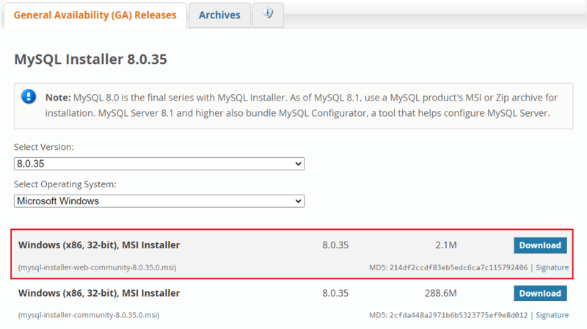

**Step 2: Go to the Downloads Section**

On the MySQL homepage, Click on the ” **No thanks, just start my download**” link to proceed MySql downloading.

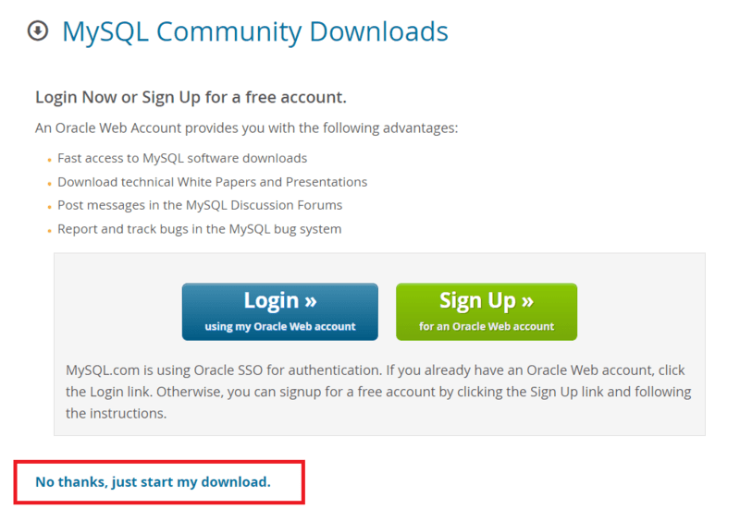

**Step 3: Run the Installer**

After MySQL downloading MySQL.exe file , go to your Downloads folder, find the file, and double-click to run the installer.

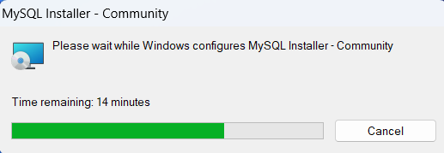

**Step 4: Choose Setup Type**

The installer will instruct you to choose the setup type. For most users, the “**Developer Defaul**t” is suitable. Click “Next” to proceed.

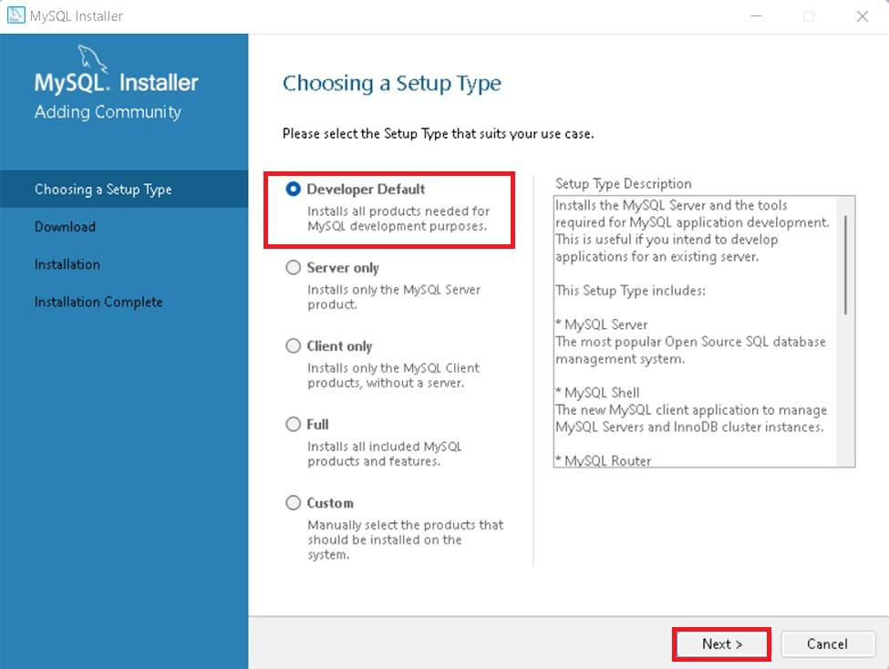

**Step 5: Check Requirements**

You might be prompted to install necessary MySQL [software](https://www.geeksforgeeks.org/software-and-its-types/), typically Visual Code. The installer can auto-resolve some issues, but not in this case.

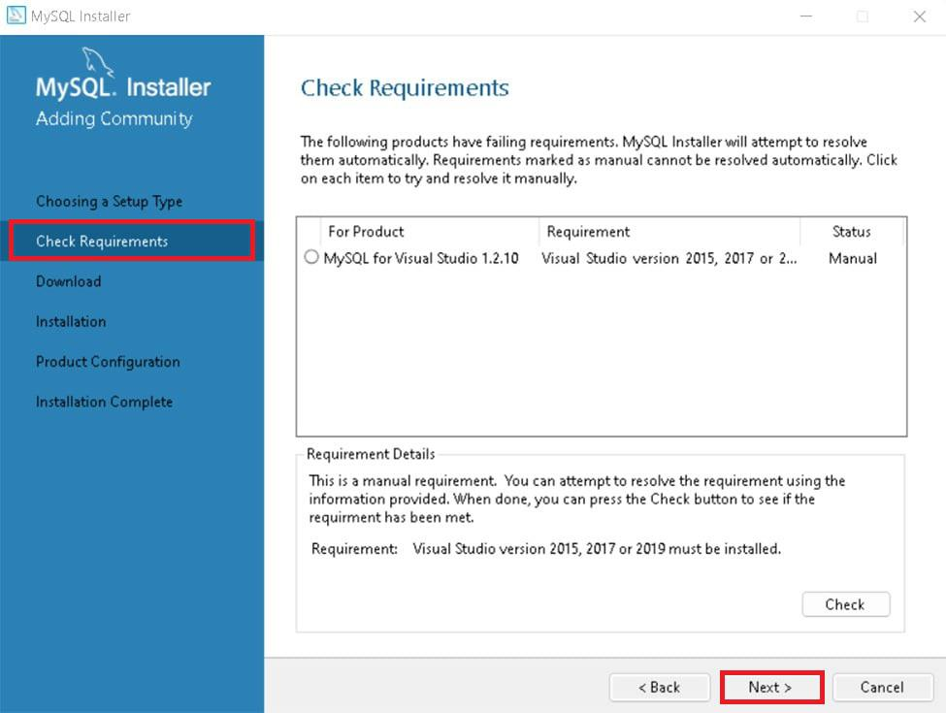

**Step 6: MySQL Downloading**

Now that you’re in the download section, click “Execute” to start downloading the components you selected. Wait a few minutes until all items show tick marks, indicating completion, before moving forward.

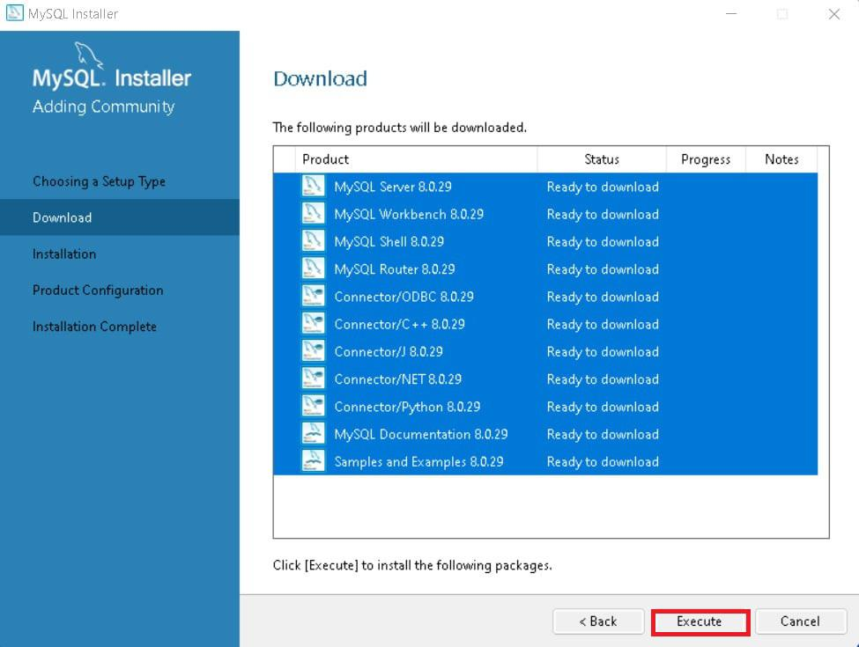

**Step 7: MySqL Installation**

Now the downloaded components will be installed. Click “**Execute**” to start the installation process. MySQL will be installed on your Windows system. Then click **Next**to proceed

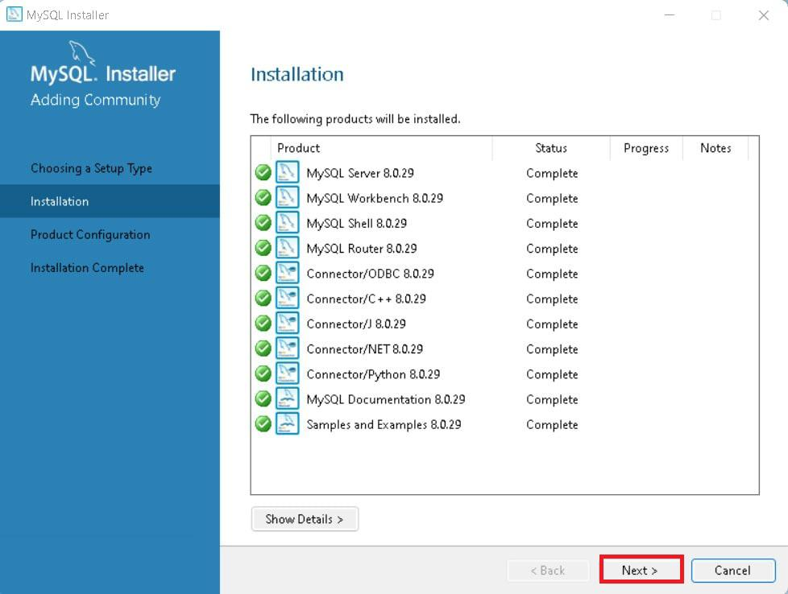

**Step 8: Navigate to Few Configuration Pages**

Proceed to “**Product Configuration**” > “**Type and Networking**” > “**Authentication Method**” Pages by clicking the “Next” button.

**Step 9: Create MySQL Accounts**

Create a password for the MySQL root user. Ensure it’s strong and memorable. Click “**Next**” to proceed.

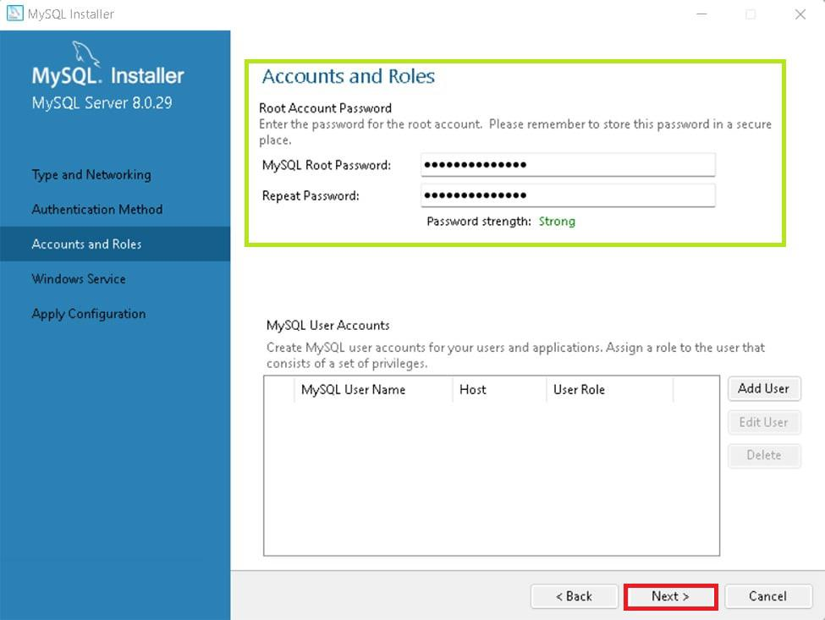

**Step 10: Connect To Server**

Enter the root password, click Check. If it says “Connection succeed,” you’ve successfully connected to the server.

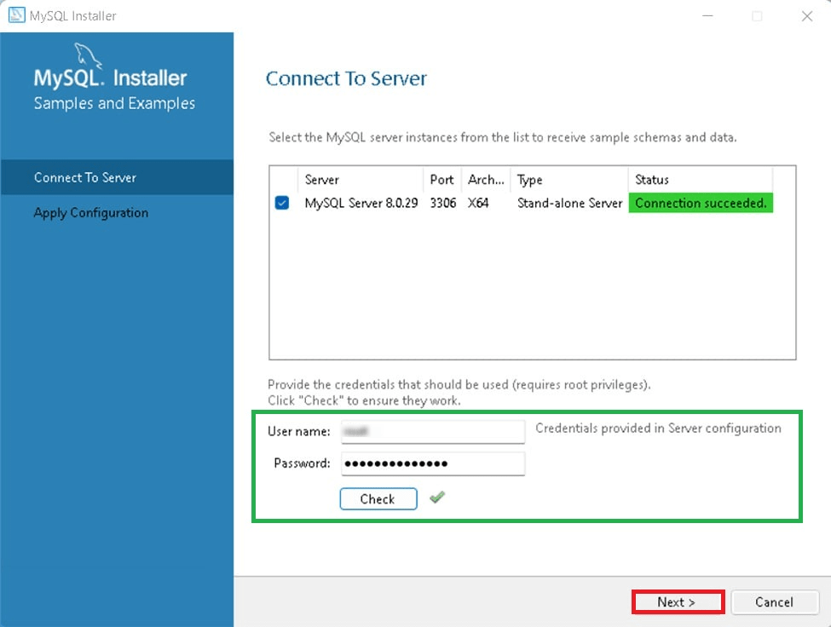

**Step 11: Complete Installation**

Once the installation is complete, click “Finish.” Congratulations! MySQL is now installed on your Windows system.

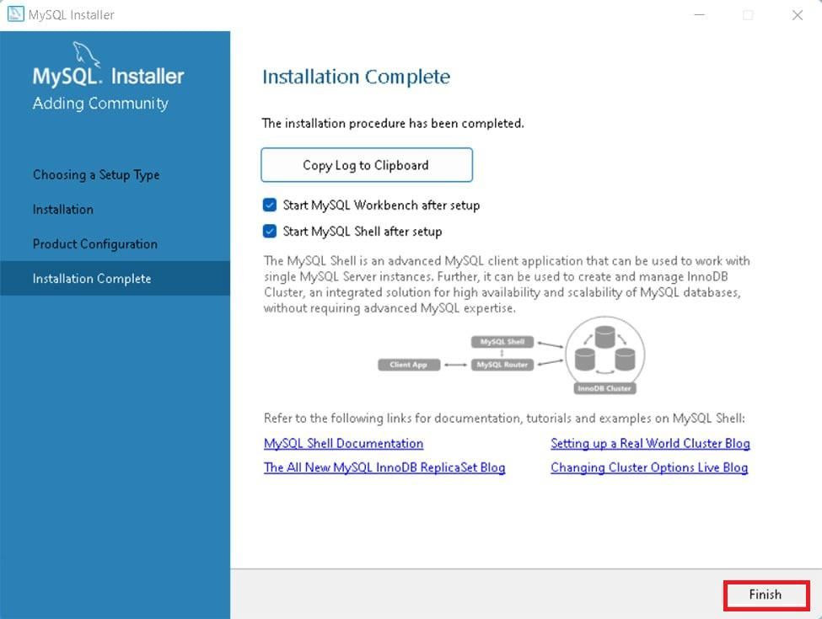

**Step 12: Verify Installation**

To ensure a successful installation of MySQL, open the MySQL Command Line Client or MySQL Workbench, both available in your Start Menu. Log in using the root user credentials you set during installation.

**MySQL Workbench Is Ready To Use**

MySQL is an open-source relational database management system that is based on [SQL queries](https://www.geeksforgeeks.org/sql-concepts-and-queries/). MySQL is used for data operations like **querying, filtering, sorting, grouping, modifying, and joining** the tables present in the database.

***Read more:***[*MySQL and its working*](https://www.geeksforgeeks.org/mysql-introdution/)

